**TerraWeek Day 6: Terraform Providers**

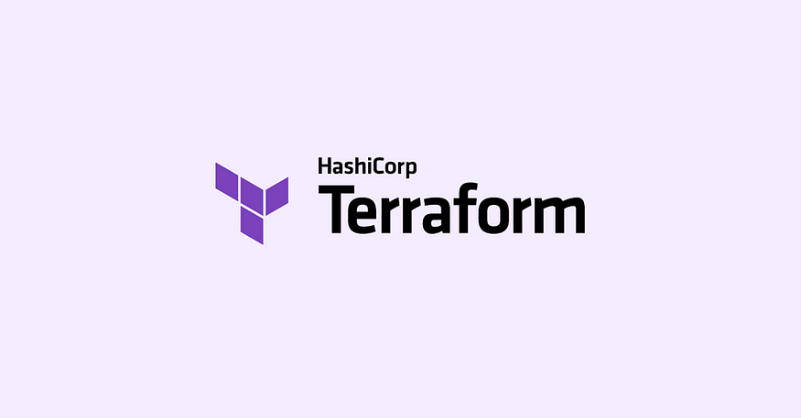

Welcome to **Day 6** of the TerraWeek challenge! 🚀 In today's tasks, we will explore **Terraform providers** and their role in interacting with different cloud platforms or infrastructure services. We will also dive into provider configuration, authentication, and hands-on practice using providers for platforms such as **AWS**, **Azure**, **Google Cloud**, or others.+

**Task 1: Learn and Compare Terraform Providers**

✨ **Objective**: Learn about Terraform providers and compare their features across different cloud platforms.

📚 **Steps**:

* Spend time learning about Terraform providers and their significance in managing resources across various cloud platforms or infrastructure services.

Terraform providers are plugins that allow Terraform to interact with different cloud platforms, infrastructure services, or APIs. They enable the provisioning and management of resources in a unified and consistent manner, regardless of the underlying technology.

The Significance of Terraform Providers:

1. Unified Resource Management: With Terraform providers, you can manage resources across multiple cloud platforms or infrastructure services using a consistent workflow. This eliminates the need for learning and using separate tools or APIs for each platform, simplifying resource management.
2. Cross-Platform Compatibility: Terraform provides a wide range of providers that support major cloud platforms such as AWS, Azure, GCP, and more. This cross-platform compatibility enables organizations to adopt a multi-cloud strategy, leveraging the strengths of each platform without the hassle of managing them individually.
3. Infrastructure as Code (IaC) Practices: Terraform providers align with Infrastructure as Code principles, allowing infrastructure configurations to be defined as code. This brings benefits like version control, collaboration, and automated provisioning, resulting in more reliable and scalable infrastructure deployments.
4. Consistency and Standardization: Terraform providers ensure consistent infrastructure provisioning and management across different cloud platforms. By using a single tool and a declarative language, you can enforce standardized configurations, reducing complexity and ensuring uniformity.
5. Extensibility and Customization: Terraform providers offer extensibility, enabling users to develop custom providers or contribute to existing ones. This flexibility allows integration with specialized APIs, internal systems, or niche cloud providers, empowering organizations to tailor their infrastructure management to specific requirements.
6. Community Support and Ecosystem: Terraform has a thriving community that actively contributes to the development and maintenance of providers. This vibrant ecosystem provides a wealth of resources, modules, and best practices, accelerating adoption and facilitating knowledge sharing.

**Task 2: Provider Configuration and Authentication**

✨ **Objective**: Explore provider configuration and set up authentication for each provider.

📚 **Steps**:

* Explore provider configuration and authentication mechanisms in Terraform.

Provider Configuration: To configure a Terraform provider, you need to define it in your Terraform configuration file (typically named **main.tf**). The provider block specifies the provider name and any required configuration variables. Here's an example of how to configure the AWS provider:

provider "aws" {

region = "us-east-1"

}

In this example, we configure the AWS provider with the **region** variable set to "us-west-2". The specific configuration options may vary depending on the provider.

Authentication Mechanisms: Authentication mechanisms vary for each Terraform provider. Here are some common authentication methods for popular providers:

1. AWS (Amazon Web Services):
   * Access Key and Secret Key: You can set the AWS access key ID and secret access key as environment variables or use the AWS CLI configuration to authenticate Terraform.
   * AWS CLI Configuration: Terraform can use the AWS CLI configuration files (**~/.aws/config** and **~/.aws/credentials**) to authenticate with AWS.
2. Azure (Microsoft Azure):
   * Service Principal Authentication: Azure uses service principals for authentication. You can create a service principal and configure its credentials (client ID, client secret, tenant ID) as environment variables or using Azure CLI configuration.
3. GCP (Google Cloud Platform):
   * Service Account Authentication: GCP requires a service account key file to authenticate Terraform. You can download the JSON key file and set the **GOOGLE_APPLICATION_CREDENTIALS** environment variable to its path.

* Set up authentication for each provider on your local machine to establish the necessary credentials for interaction with the respective cloud platforms.

Setting Up Authentication: To set up authentication for each provider on your local machine, follow these general steps:

1. Install and configure the respective CLI tool (AWS CLI, Azure CLI, GCP CLI, OCI CLI, DigitalOcean CLI) if required.
2. Obtain the necessary credentials for the provider:
   * AWS: Obtain an access key ID and secret access key.
   * Azure: Create a service principal and obtain the required credentials.
   * GCP: Generate a service account key file.
3. Set the credentials as environment variables or configure them in the respective CLI tool.
4. Define the provider configuration block in your Terraform configuration file, specifying the required variables such as region, credentials file path, access key, etc.
5. Run **terraform init** to initialize your Terraform configuration and download the necessary provider plugins.

With the authentication set up, you can now use Terraform to provision and manage resources in the respective cloud platforms by executing **terraform apply**, **terraform plan**, or other Terraform commands.

**Task 3: Practice Using Providers**

✨ **Objective**: Gain hands-on experience using Terraform providers for your chosen cloud platform.

📚 **Steps**:

Step1 : Create a new directory named "terraweek_day6" and navigate into it.

mkdir terraweek_day6

cd terraweek_day6



Step2 : Create a main.tf file within “terraweek_day6” directory.

nano main.tf

Step3 : Open the main.tf file within the terraweek_day6 directory and add the following code to define the EC2 instance resource:

1. AWS Provider:
   * Specifies the AWS provider and sets the region to "us-east-1".

provider "aws" {

region="us-east-1"

}

1. EC2 Instance (resource "aws_instance"):
   * Deploys an EC2 instance using the specified Amazon Machine Image (AMI) ID and instance type.
   * Associates a security group, key pair, and tags to the instance.

resource "aws_instance" "myec2" {

ami= "ami-0d81306eddc614a45"

instance_type= "t2.small"

vpc_security_group_ids=[aws_security_group.ownsg.id]

key_name = "tf-key-pair"

tags={

Name="terraform-example"

}

}

1. Security Group (resource "aws_security_group"):

* Creates a security group allowing inbound traffic on port 80 (HTTP) from any source.

resource "aws_security_group" "ownsg" {

name="own-sg"

ingress {

from_port=80

to_port=80

protocol="tcp"

cidr_blocks=["0.0.0.0/0"]

}

}

1. Key Pair (resource "aws_key_pair"):

* Generates an RSA key pair for SSH access to the EC2 instance.
* The private key is saved locally, and the public key is associated with the key pair resource.

resource "aws_key_pair" "tf-key-pair" {

key_name = "tf-key-pair"

public_key = tls_private_key.rsa.public_key_openssh

}

resource "tls_private_key" "rsa" {

algorithm = "RSA"

rsa_bits = 4096

}

resource "local_file" "tf-key" {

content = tls_private_key.rsa.private_key_pem

filename = "tf-key-pair"

}

1. VPC (resource "aws_vpc"):

* Creates a custom VPC with the specified CIDR block.

resource "aws_vpc" "customvpc" {

cidr_block = "10.0.0.0/16"

tags = {

Name = "Custom vpc"

}

}

1. Internet Gateway (resource "aws_internet_gateway"):

* Creates an internet gateway and associates it with the custom VPC.

resource "aws_internet_gateway" "custominternetgateway" {

vpc_id = aws_vpc.customvpc.id

}

1. Subnet (resource "aws_subnet"):

* Creates a subnet within the custom VPC with the specified CIDR block and availability zone.

resource "aws_subnet" "mysubnet" {

cidr_block = "10.0.0.0/20"

vpc_id = aws_vpc.customvpc.id

availability_zone = "us-east-1a"

}

1. Route Table (resource "aws_route_table"):

* Creates a route table associated with the custom VPC.
* Adds a default route to the internet gateway.

resource "aws_route_table" "publicrt" {

vpc_id = aws_vpc.customvpc.id

route {

cidr_block = "0.0.0.0/0"

gateway_id = aws_internet_gateway.custominternetgateway.id

}

}

1. Route Table Association (resource "aws_route_table_association"):

* Associates the subnet with the route table.

resource "aws_route_table_association" "public_association" {

subnet_id = aws_subnet.mysubnet.id

route_table_id = aws_route_table.publicrt.id

}

provider "aws" {

  region="us-east-1"

 }

 #EC2 resource

 resource "aws_instance" "myec2" {

 ami= "ami-0d81306eddc614a45"

 instance_type= "t2.small"

 vpc_security_group_ids=[aws_security_group.ownsg.id]

 key_name = "tf-key-pair"

 tags={

  Name="terraform-example"

 }

 }

 #Security Group resource for  instance

 resource "aws_security_group" "ownsg" {

  name="own-sg"

 ingress {

  from_port=80

  to_port=80

 protocol="tcp"

 cidr_blocks=["0.0.0.0/0"]

 }

 }

 #key-pair resource for instance

 resource "aws_key_pair" "tf-key-pair" {

 key_name = "tf-key-pair"

 public_key = tls_private_key.rsa.public_key_openssh

 }

 resource "tls_private_key" "rsa" {

 algorithm = "RSA"

 rsa_bits  = 4096

 }

 resource "local_file" "tf-key" {

 content  = tls_private_key.rsa.private_key_pem

 filename = "tf-key-pair"

 }

 # VPC resource for instance

 resource "aws_vpc" "customvpc" {

  cidr_block = "10.0.0.0/16"

  tags = {

    Name = "Custom vpc"

  }

}

# Internet Gateway resource

resource "aws_internet_gateway" "custominternetgateway" {

  vpc_id = aws_vpc.customvpc.id

}

#Subnet resource

resource "aws_subnet" "mysubnet" {

  cidr_block        = "10.0.0.0/20"

  vpc_id            = aws_vpc.customvpc.id

  availability_zone = "us-east-1a"

}

# Route Table resource

resource "aws_route_table" "publicrt" {

  vpc_id = aws_vpc.customvpc.id

  route {

    cidr_block = "0.0.0.0/0"

    gateway_id = aws_internet_gateway.custominternetgateway.id

  }

}

resource "aws_route_table_association" "public_association" {

  subnet_id      = aws_subnet.mysubnet.id

  route_table_id = aws_route_table.publicrt.id

}

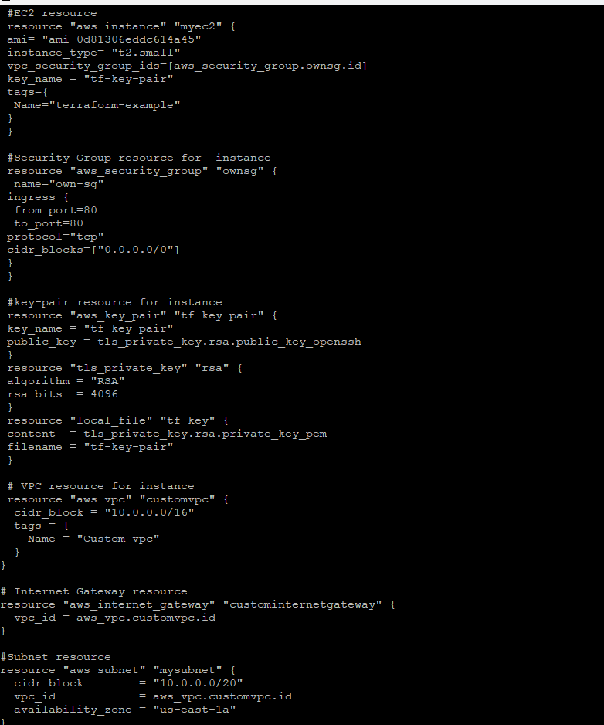

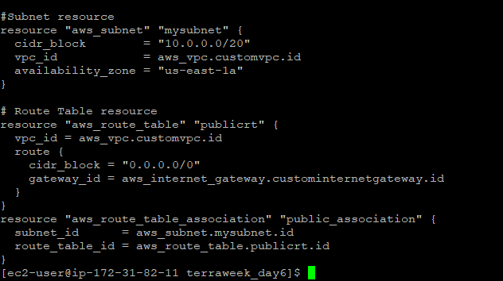

Step 4: Authenticate with the chosen cloud platform using the appropriate authentication method (e.g., access keys, service principals, or application default credentials).

* To configure the AWS CLI on your local machine by running the following commands in your terminal:

Use export commands

export AWS_ACCESS_KEY_ID=

export AWS_SECRET_ACCESS_KEY=

Step 5**:** Run the terraform init command to initialize Terraform and configure the backend.

terraform init

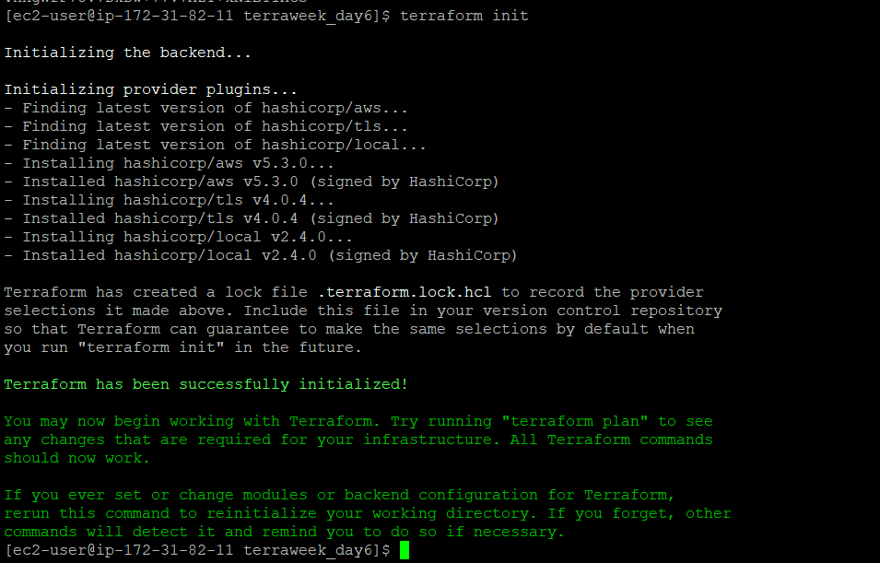

Step 6: Run **terraform plan** to preview the planned changes.

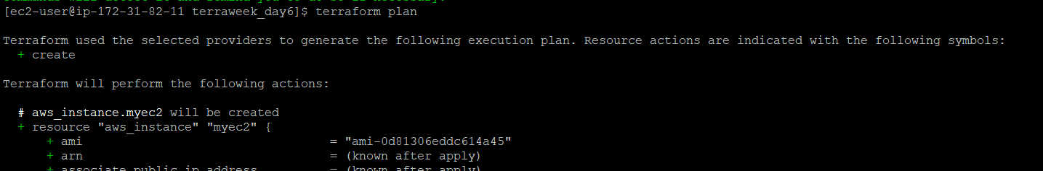

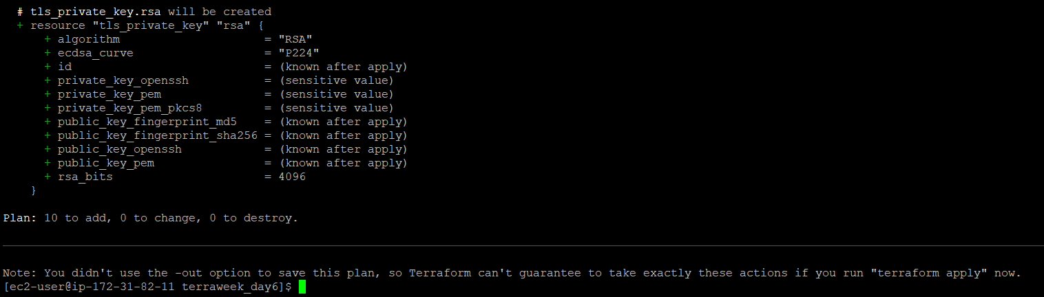

Step 7: If the plan looks correct, run **terraform apply** and confirm the changes to deploy the resources.

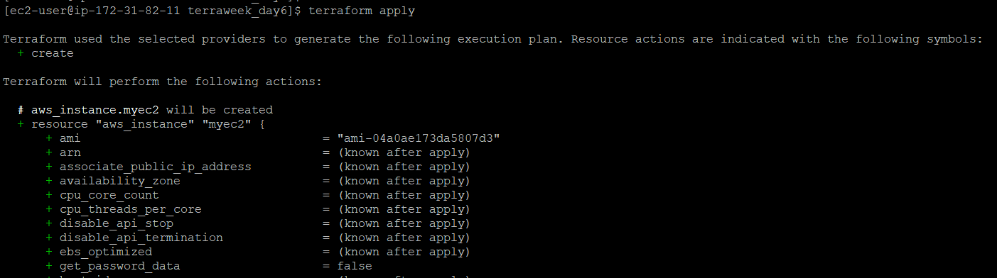

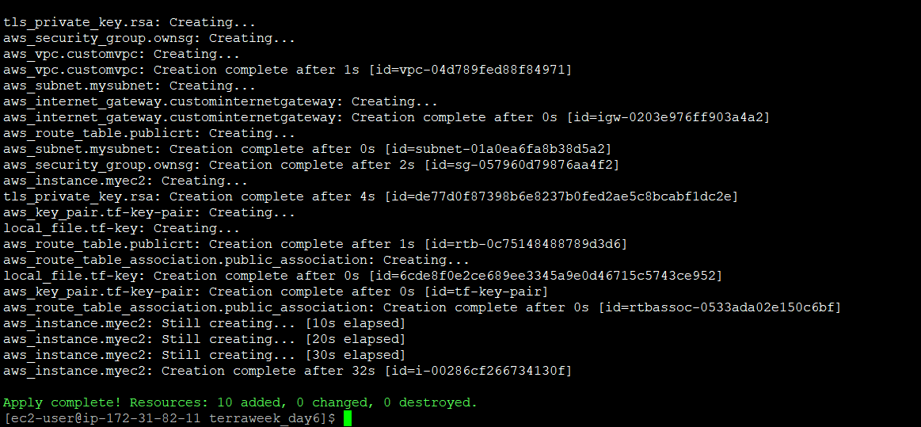

Step 8: Once you are done experimenting, use the terraform destroy command to clean up and remove the created resources.

terraform destroy

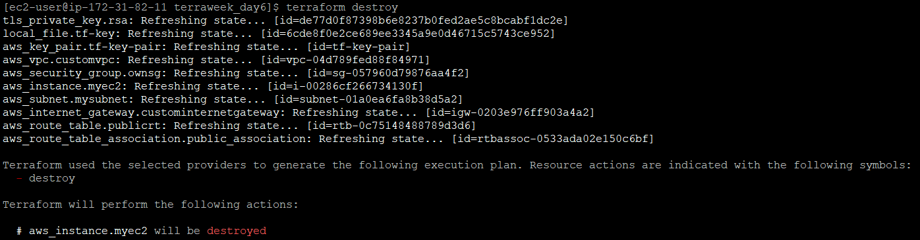

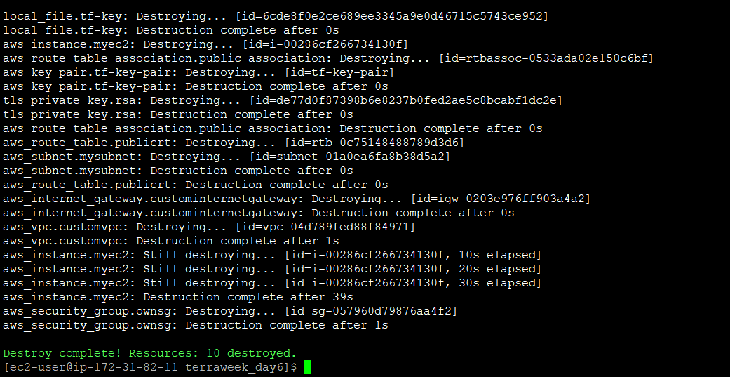

**Happy Learning! 🌍💻**

**Conclusion:**

From this blog we can conclude, Terraform providers play a crucial role in managing resources across various cloud platforms or infrastructure services. They provide a unified and consistent workflow for provisioning and managing resources, enabling organizations to adopt a multi-cloud strategy and align with Infrastructure as Code principles.

To configure a Terraform provider, you need to define it in your Terraform configuration file and set up authentication mechanisms specific to each provider. This typically involves obtaining necessary credentials, such as access keys, service principals, or key files, and configuring them either as environment variables or in the respective CLI tools.

By following the provided steps, you can gain hands-on experience using Terraform providers for your chosen cloud platform. You'll be able to define resources, set up authentication, initialize Terraform, preview and apply changes, and ultimately manage your infrastructure efficiently.

Embracing Terraform providers and leveraging their benefits, such as community support, ecosystem resources, and Infrastructure as Code practices, empowers organizations to build reliable, scalable, and easily maintainable infrastructure deployments across diverse cloud platforms

🌟 Excited to share my experience with Terraform providers on Day 6 of #TerraWeek! 🚀

During today's tasks, I explored the power of Terraform providers and their role in managing resources across different cloud platforms and infrastructure services. Here's what I learned:

In Task 1,Learn about Terraform providers and compare their features across different cloud platforms.

In Task 2, I explored provider configuration and authentication mechanisms. Each provider has its own way of authentication, such as using access keys and secret keys for AWS, service principals for Azure, and service account key files for GCP.

In Task 3, I gained hands-on experience using Terraform providers for my chosen cloud platform. I defined an EC2 instance, security group, key pair, VPC, subnet, route table, and more, all within a single Terraform configuration file. The process was smooth and efficient!

Terraform's ability to abstract the complexities of interacting with different cloud platforms through providers is truly remarkable. It simplifies resource management, promotes standardization, and allows for customization when needed.

I can't wait to continue exploring Terraform's capabilities and dive deeper into infrastructure automation. Stay tuned for more updates as #TerraWeek continues! 🌍💻 #InfrastructureAsCode #CloudManagement